Chapter 2

Mobile Learning Literature Review in Medical Education

Heeyoung Han¹, PhD, Larry Hurtubise², MA,
Geraud Plantegenest³, MA, Carolyn R. Rohrer Vitek⁴, MS,
Rahul Patwari⁵, MD, Cecile Foshee⁶, PhD,
and Elissa R. Hall⁷, EdD (ABD)*
¹ Department of Medical Education, Southern Illinois University School of Medicine,
Springfield, Illinois, USA
² Family Medicine, Heritage College of Osteopathic Medicine Dublin, Dublin, Ohio, USA
³ Blended Curricular Learning Resources (B-CLR), Michigan State University College of Human Medicine, East Lansing, Michigan, USA
⁴ Center for Individualized Medicine, Mayo Clinic, Rochester, Minnesota, USA
⁵ Department of Emergency Medicine, Rush University, Chicago, Illinois, USA
⁶ Graduate Medical Education Curriculum Development, Cleveland Clinic, OH, USA
⁷ Department of Laboratory Medicine and Pathology, Mayo Clinic Rochester, MN, USA

Abstract

Mobile learning has become a new learning modality, yet most practices of designing and developing mobile learning in medical education are often a theoretical with neither solid conceptual basis nor evidence-based instructional strategies. This paper aims to provide a literature review that investigates mobile learning instructional design strategies that were found to be effective in medical education. We conducted a literature search from 2010 to December 2015. An initial search yielded 1,196 articles, which were narrowed down to 28 papers for analysis based on exclusion and inclusion criteria. Adopting a qualitative synthesis methodology, we used an iterative data analysis approach using an inductive and deductive process to identify themes. Studies were from various disciplines: Emergency medicine, surgery, pediatrics, nursing, pharmacology. The qualitative synthesis of literature suggested six themes. (1) Timeliness capturing learning experience and assessing performance: The focus of this mobile learning process is on capturing learning activities and providing feedback on the spot. (2) Pushed reminders for knowledge learning and behavior change: Using simple text messages were found to be effective and can be extended to a more sophisticated personalized scaffolding. (3) Visual modeling for performance just in time: This instructional strategy often involves reducing extraneous cognitive load on the spot, providing worked examples right before performing a critical task, and visualizing learning object in three dimensional presentations. (4) Facilitating collaborative informal learning: The underlying concept to support this mobile learning pedagogy is informal work-based learning and social learning process. (5) Mixed evidence of multimedia: There was no consistent evidence that multimedia such as videos is more effective than traditional media for knowledge learning. (6) Simulated immersive clinical experience: The underlying premise is that mobile simulations and gaming provide virtual immersive clinical experiences with opportunities for repeated practice at their fingertips without risk. These six themes are not exclusive, but combined to create optimized effective mobile learning experiences. These study findings provide that mobile learning is a pedagogical process enriched by context-sensitivity of being (location) and doing (activity) of a learner or a teacher. It is a comprehensive process to create meaningful instructional and learning interactions in consideration of where learners and teachers will be and what they will be doing. Simple transferring decontextualized traditional curriculum activities via a mobile device can have limited effectiveness. Future studies could focus on further applicability to various contexts in medical education.

Keywords: literature review, mobile technologies, smart phones

Introduction

For the last decade, the concept of mobile learning has been discussed and defined from various perspectives. From the perspective of technical attributes, mobile learning can be defined as learning that makes use of mobile technologies (Sharples, 2000). This techno-centric perspective focuses on the physical aspect of technologies; that is, the hardware, the software, and specific characteristics of mobile devices. This view has been challenged and has evolved to include a broader understanding of the technological phenomenon with an increased focus on the nature of ubiquitous learning embracing seamless learning context (Toh et al., 2013; El-Hussein and Cronje, 2010; Traxler, 2007). In this view, mobile learning is defined as a meaningful learning process “that occurs when learners have access to information anytime and anywhere via mobile technologies to perform authentic activities in the context of their learning” (p.77, Martin and Ertzberger, 2013).Nunc viverra imperdiet enim. Fusce est. Vivamus a tellus.
The notion of ubiquitous mobile learning − learning anywhere and anytime − indicates a pragmatic understanding of learning experiences especially in an informal format that happens beyond classroom settings and resides in daily activities (Merriam and Bierema, 2014). The majority of adults engage in hundreds of hours of informal learning (Caffarella and Merriam, 2012); therefore, a unique aspect of mobile learning is that it is a “personal, contextual, and situated” learning process, especially emphasizing individuals’ informal and unstructured experiences (Traxler, 2007). Recognizing the disruptive nature of mobile learning regardless of location and time, it is imperative to understand what design strategies and approaches have been found to be effective in mobile learning.

Mobile Learning Literature Review in Medical Education

The recent influx of mobile technologies such as smart phones and tablet computers has profoundly influenced people’s daily activities. As mobile devices continue to diminish in size, their computing capacity is expanding at unprecedented rates providing users with increased on-the-go access, powerful information processing capabilities, and social opportunities. This mobility and instant connectivity phenomenon changes not only how people interact and share information but also presents educational opportunities across fields and academic levels—hence the coining of the term mobile learning.

Pushed Reminders For Knowledge Learning And Behavior Change
Pushed information or reminders using simple text messages were found to be effective in enhancing medical learners’ knowledge acquisition and retention (Chuang and Tsao, 2013; Diedhiou et al., 2015; Walter et al., 2014; Alipour, Jannat and Hosseini, 2014).
In a study in nursing education, students provided with SMS learning resources two times a day showed higher scores in a medical knowledge test than those without SMS observed at one week, two weeks, and four weeks after the intervention (Chuang and Tsao, 2013). Simple text messaging was an effective on-the-job training process for healthcare learners for their continuing education without disrupting their patient care work routine (Diedhiou et al., 2015; Alipour, Jannat and Hosseini, 2014). Most studies attributed the positive effect to spaced education principle and feasibility of mobile learning process to support the pedagogy (Chuang and Tsao, 2013; Diedhiou et al., 2015).

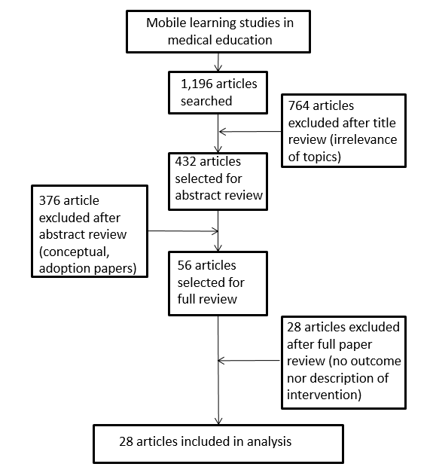
Figure 1. Inclusion and exclusion process.
Visual modeling for performance just in time
Visual modeling for performance just in time is another central instructional approach for effective mobile learning. This instructional strategy often involves reducing extraneous cognitive load on the spot, providing worked examples right before performing a critical task, and visualizing learning object in three dimensional presentations.

There are several limitations in this study. The selection of the database, key words, and years may not include studies available in other databases and journals. Additionally, there may be a selection bias from unpublished studies showing no effects or benefits to mobile learning.
Findings in this study may not represent all possible instructional strategies exhaustively but provided some of the potentials of mobile learning processes. Simply adopting traditional e-learning approaches may not necessarily lead to positive mobile learning experiences as mobile learning leans more toward informal, personal, context-oriented, instant, and opportunistic experiences rather than formal, structured, and media-rich traditional e-learning experiences (Traxler, 2007). More insightful, thoughtful, and innovative design approaches aligned with the mobile learning characteristics should be investigated and studied.

Hawkes et al. (2013) investigated the effect of short visual instruction right before performing newborn intubation and found that this approach was effective for improving both knowledge and procedural skills for novice learners. Medical students performed better with patient encounters in an emergency department setting when they had immediate access to an instructional video right before seeing a patient in the emergency room (Tews et al., 2011). A similar effect was found in another study. According to Noguera et al. (2013), when second year students in physical therapy had access to two- or three-dimensional images of anatomy on their mobile devices during a practice session, their knowledge gain was higher than those who did not have such learning environments. With resources on their mobile devices, the students were able to visualize specific anatomy of knee, ankle, and pelvic zone as they practiced physical therapy. This allowed the participants to deeply engage in learning how physical therapy works in relation to a specific anatomy structure.

Table 1. Summary of included articles

Population | Specialty domain | Intervention  (Mobile Technology) | Conceptual framework / Instructional design features
Undergraduate medical education (UME) | Emergency medicine | Videos delivered on a mobile device | Just-in-time (JIT) learning  Watching the instructional video before entering a patient room
Physician Assistant(PA)/Nursing/Medic/Tech | Military trauma | Learning modules delivered on a mobile device | JIT learning
Nursing | Pharmacology | Short message service (SMS) | Information processing theory  Providing reminders to review the content

Discussion

Findings of the current study suggest several instructional design frameworks of mobile learning. These design approaches are identified and discussed with an educational belief that mobile learning should go beyond a simple techno-centric view that introducing a mobile device technology to instructional activities would automatically provide positive pedagogical effects. As seen in the literature review of this paper, utilizing mobile technology should be perceived as a technological process to design authentic learning experiences (Han, Resch and Kovach, 2013). Thoughtful design of learning experience considering person, time, and place where learning experiences occur is the key for a meaningful mobile learning process.
Mobile learning is a pedagogical process enriched by context-sensitivity of being (location) and doing (activity) of a learner or a teacher. It is a comprehensive process to create meaningful instructional and learning interactions in consideration of where learners and teachers will be and what they will be doing. Simple transferring decontextualized traditional curriculum activities via a mobile device can have limited effectiveness. The mobile leaning pedagogical question is not only about making instructions or guidance available for just-in-time learning, but also about creating an expert presence for a specific individual that facilitates context-based learning and performance in an authentic situation.

Disclaimer

None

References

Alipour S, Jannat F, Hosseini L. Teaching Breast Cancer Screening via Text Messages as Part of Continuing Education for Working Nurses: A Case-control Study. Asian Pac J Cancer P (2014) 15(14):5607-5609.
Baran E. A Review of Research on Mobile Learning in Teacher Education. Educational Technology & Society (2014) 17(4):17-32.
Bearman M, Dawson P. Qualitative synthesis and systematic review in health professions education. Medical Education (2013) 47(3):252-260.
Caffarella RS, Merriam SB. Learning in adulthood: A comprehensive guide. San Francisco, CA: Jossey-Bass; 2012.
Chen C-C, Huang T-C. Learning in a u-Museum: Developing a context-aware ubiquitous learning environment. Computers & Education (2012) 59(3):873-883.
Chu H-C, Hwang G-J, Tsai C-C, et al. A two-tier test approach to developing location-aware mobile learning systems for natural science courses. Computers & Education (2010) 55(4):1618-1627.
Chuang YH, Tsao CW. Enhancing nursing students' medication knowledge: The effect of learning materials delivered by short message service. Computers & Education (2013) 61:168-175.
Cook DA, West CP. Conducting systematic reviews in medical education: a stepwise approach. Medical Education (2012) 46(10):943-952.

* Corresponding Author’s Email: hhan@siumed.edu.

